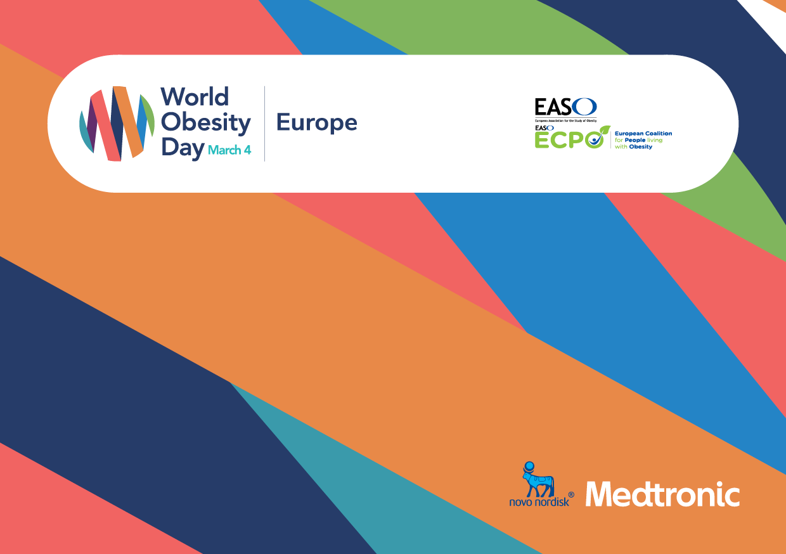

ADDRESSING OBESITY  
TOGETHER   
ACROSS EUROPE

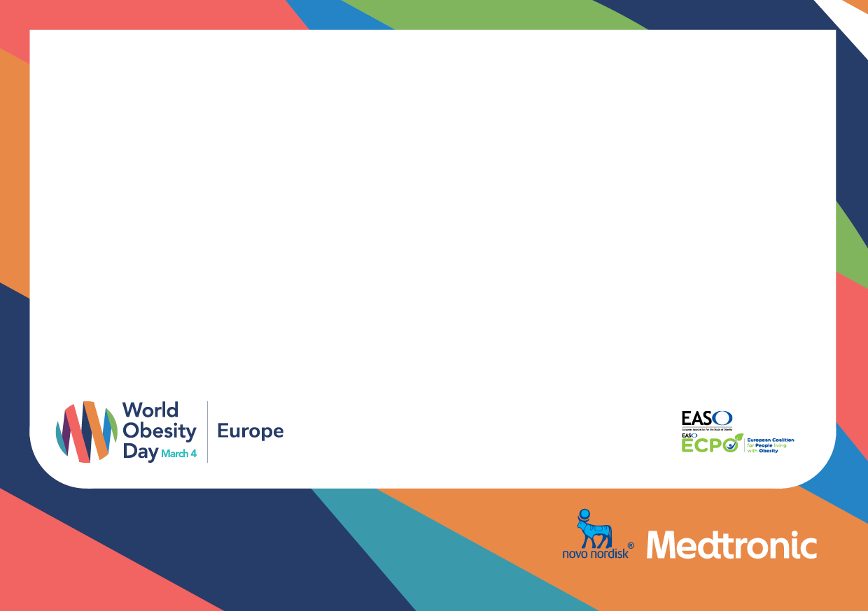

www.woday

#ObesityDayEurope

In Europe, the aim is to increase knowledge and understanding of the need for action at both European and national levels to improve prevention, treatment and care. At the same time, the campaign supports overweight and obese citizens in making the necessary lifestyle changes to manage their weight and improve their overall health and quality of life.

Three reasons to support our activities

1. You will be part of a dynamic campaigning network

2. You will be joining a recognised voice on obesity

3. WOD provides opportunities for involvement at   
national and EU level

Join us and let us help you ensure your organisation plays an active and visible role in the World Obesity debate.

World Obesity Day 2021 will be held on 4th March 2021 and is a campaign platform of many of the world’s leading obesity organisations, including the European Association for the Study of Obesity (EASO).

It brings together healthcare, patient and political communities who are keen to raise awareness of obesity and the other diseases on which it impacts.